

PROJECT AND TEAM INFORMATION

Project Title

AI DRIVEN SMART TRAFFIC MANAGEMENT

Student/Team Information

Team Name: Byteforcce
Team # : Stat-IV-T041
Team member 1 (Team Lead) | Bisht, Aditya – 230213801 aadityabisht34@gmail.com  
Team member 2 | Pun, Shivraj –  23011680 @gmail.com  
Team member 3 | Iris Rana, Hanul – 230221555 Hanulirisranal@gmail.com  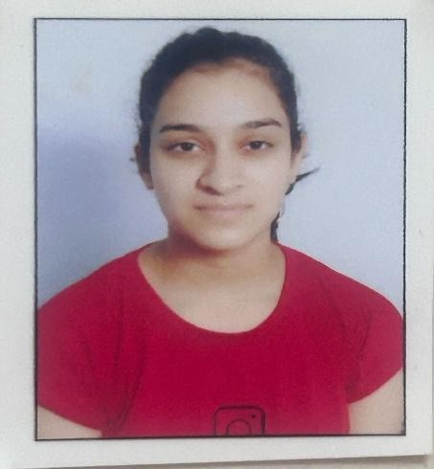
Team member 4 | Kimothi, Aditya – 23021776 adityakimothi31@gmail.com  

PROJECT PROGRESS DESCRIPTION

Project Abstract
Urban areas suffer from unpredictable traffic congestion, leading to delays, fuel waste, and frustration. Current traffic signals operate on fixed timers, which fail to account for real-time congestion levels. We aim to create a machine learning-based system that predicts traffic congestion at major intersections using historical data (time, day, vehicle count), enabling dynamic traffic light adjustments and better planning for peak times. Our system focuses on prediction, not hardware deployment, making it simple, cost-effective, and student-project-friendly.

Updated Project Approach and Architecture
We will use Python, Pandas, Scikit-learn, and Streamlit. The traffic dataset (simulated or public) will contain fields like time of day, day of week, and vehicle count.

R programing language for entire pipelining: Linear regression, via packages. Target: Predict congestion level as a numeric index
Frontend: Streamlit for visual interaction with the model
The model will be trained and validated, then wrapped with an interface where users can input day/time to see predicted congestion.
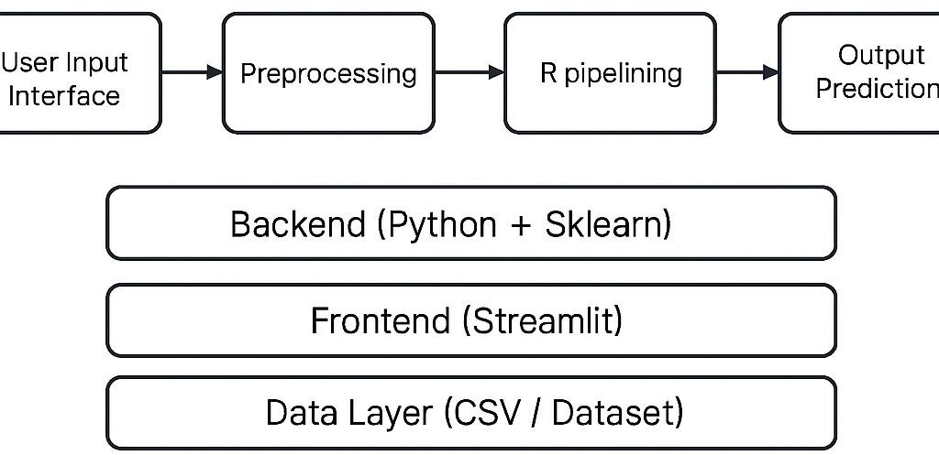

Tasks Completed
Task Completed | Team Member
- Developed Huffman coding-based text compression and decompression module  - Implemented grayscale image compression and decompression using Huffman coding with Pillow and NumPy  - Designed and built a Huffman-based audio compression module for WAV files using Python’s wave and struct libraries.  - Set up the Flask-based web interface for file upload, processing, and downloading | Priyanshu Rawat  Ajay Singh  Anshul Bhatt  Shivraj

Challenges/Roadblocks
During the development of the project, we faced several challenges across different stages. One of the main difficulties was related to Data Quality related to historical data and making it generalized for all the traffic trends all around the locations.
Integrating everything into the Streamlit also came with some difficulties. Managing input of destination and start location in one interface, and processing them asynchronously created complexity in accurate route handling for destinations and start locations
Additionally, Model Training needed to be handled with care to avoid overfitting or underfitting during multiple processing stages. Ensuring consistency in input of location via csv across all destinations was time-consuming but necessary.
To solve these problems, we used a modular design approach and tested each module separately before integrating them. We also referred to official documentation and open-source examples to guide our implementations.

Tasks Pending
Task Pending | Team Member (to complete the task)
- Full scale integration into GUI  - Better and efficient Model training | Aditya Kimothi  Shivraj Pun

Project Outcome/Deliverables
The final outcome of the project will be a functional and modular web-based application that supports intelligent identification of traffic trends and coping it with use of prediction of traffic trends to remove any congestion present in traffic. The users can use this app to take a better route if present then handle the traffic situations which will benefit the whole population at large.
- An R-based engine for traffic congestion prediction
- A web-based app interface (Streamlit)
- Documentation of implementation, dataset, and performance metrics
- Future scope section for IoT extension (optional)

Progress Overview
The development of the project is progressing steadily. The major functional modules, including the pipelining using R for regression models and functional GUI are present.
However, these modules are currently operating independently and have not yet been fully integrated into the main Streamlit interface. Due to minor system-level differences and pending integration logic, the combined functionality (selecting desired current and destination location and finding better route through the web app) is still under development.
Also, predicting accurate current condition of traffic and full UI polishing, are pending and will be taken up in the next development cycle. Error handling and file validation mechanisms for input of historical traffic trends also need to be implemented post-integration.
Despite this, the team is on track with the project timeline. Each member has completed their assigned modules, and once integration is achieved, full-system testing and debugging will begin. No major bottlenecks are expected, and the final version is expected to be ready on time with all key features working as intended.

Codebase Information
The project code is hosted on GitHub. Each functional module developed in separate scripts and committed to the repository. Currently, modules are being tested individually, and integration is the next focus.
Repository Link: Ai-Traffic-System-PBL

Testing and Validation Status
Test Type | Status (Pass/Fail) | Notes
- XGBoost Training Model in R  - GUI using Streamlit  - Data Collection with csv files  - Integration of work in single system | Pass  Pass  Pass  Pending | Tested with csv inputs and it gave consistent results  Gave a user friendly user interface  The historical data of traffic trends was recorded consistently  The GUI still needs polishing and system pipelining needs to be integrated.

Deliverables Progress
A trained ML model for prediction of unseen traffic data | Completed
User Friendly GUI using Streamlit | Completed
User input by location and destination | Completed
Full Scale integration of project | Pending
All core modules have been successfully developed and tested independently. Integration, along with decompression, error handling, and UI refinement, will be the primary focus in the coming development phase.

